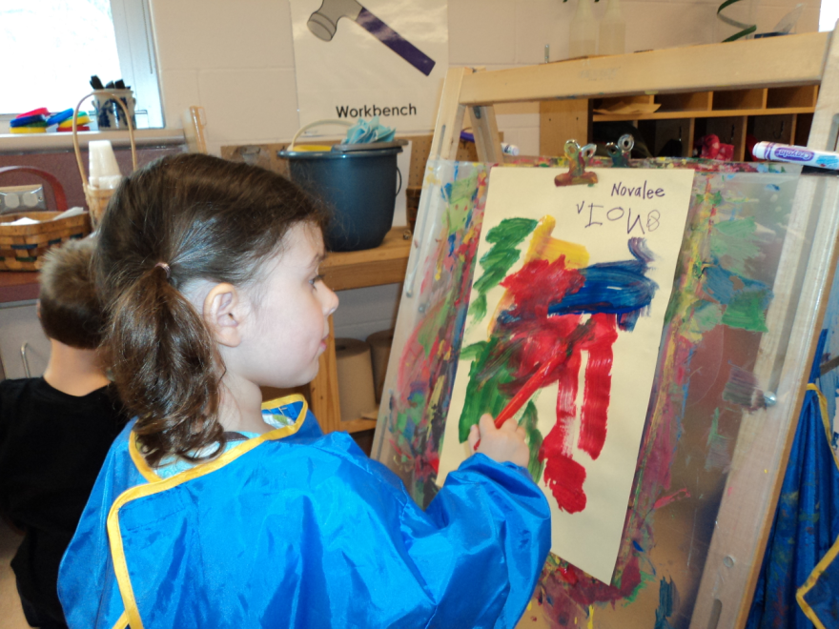

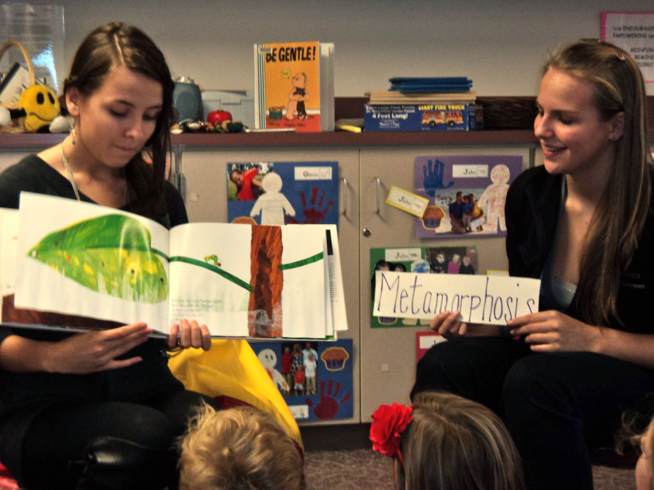

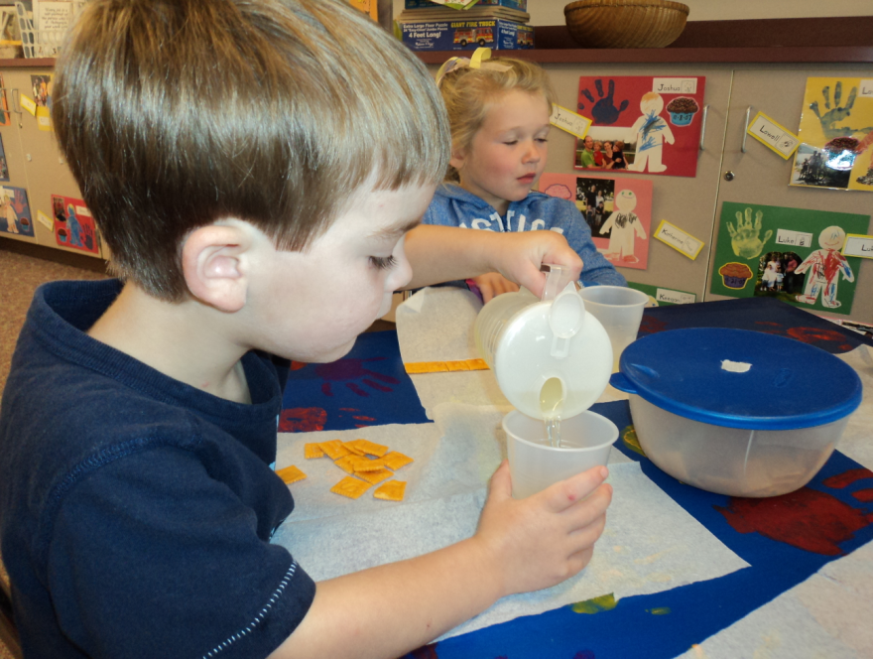

TRI-TOWN PROGRAM STAFF

Barbara Tully, Head Teacher - Preschool
btully@orr.mec.edu
Geralyn Dias, Child Development Teacher - High School gdias@orr.mec.edu

Tri-Town Early Childhood Program Website
orrhsprek.weebly.com

Central Office Staff
Douglas R. White, Jr., Superintendent
dwhite@orr.mec.edu
Michael Nelson, Director of Student Services
mnelson@orr.mec.edu
Dr. Elise Frangos, Assistant Superintendent efrangos@orr.mec.edu

Building Principals
Center School, Rosemary Bowman
Old Hammondtown, Charlie Egan
Rochester Memorial School, Derek J. Medeiros
Sippican Elementary School, Evelyn Rivet
Old Rochester Regional JHS, Kevin Brogioli
Old Rochester Regional HS, Michael Devoll
mdevoll@orr.mec.edu

Early Childhood Office
Doreen Lopes, Early Childhood Coordinator
dlopes@orr.mec.edu

District Website www.oldrochester.org

The Old Rochester Regional School District does not discriminate on the basis of race, color, national origin, age, sex, religion, sexual orientation, homelessness or disability in admission to, access to, treatment in or employment in its programs and activities.

Tri-Town
Early Childhood
Program

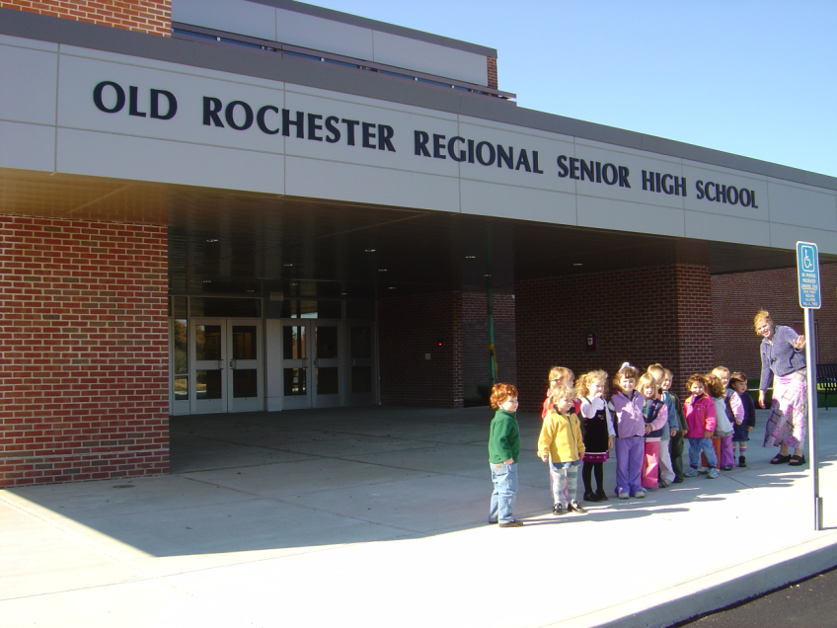

Marion
~ Mattapoisett ~
Rochester

“. . . inspiring all students to think,
to learn, to achieve and to care”

Our Philosophy

Children are learning from the moment of birth. They learn to move, to manipulate, to communicate, to interact with others, to solve problems, to understand how things work. They arrive at their first “school” day as active, experienced learners. It is the goal of the Early Childhood Classroom to continue this natural process of learning at school. It is the responsibility of the Early Childhood Teacher to create an environment that allows for active exploration and involvement with materials, concepts, and experiences. In our early childhood classrooms children are respected for their ability to pursue their own learning, with the support of early childhood professionals who understand how children grow and develop.

Our Curriculum

The Tri-Town Early Childhood Program uses the High/Scope Curriculum. It provides a framework in which our philosophy may be put into action. Children follow a classroom routine that includes the PLAN ~ DO ~ REVIEW sequence, a process that allows children to take responsibility for their actions in a structured way. They learn that each person can develop a unique idea, carry it out, and evaluate it. Elements of the Get Set for School Curriculum and Teaching Strategies Gold Curriculum support our young learners with the development of kindergarten readiness skills. We use strategies of the Responsive Classroom Curriculum to build a cooperative and respectful community of learners. Our preschool learning experiences are aligned with the MA Guidelines for preschool learning and the Common Core State Standards adopted in January 2011.

Location

Old Rochester Regional High School; 135 Marion Road, Mattapoisett, MA 02739

The program follows the school year calendar. Parents provide transportation.

In addition to providing a high quality preschool experience, the Tri-Town Early Childhood Program serves as a model setting for high school students interested in Early Childhood Education. Under the direction of the high school and preschool teacher, high school students learn, practice, and master the skills necessary to support young learners in a preschool classroom. The National Association for the Education of Young Children (NAEYC) has accredited this program.

Program Fees*

Preschool Fee: (9:00 a.m. to 12:00 noon)
$3,600 a year for 5 days a week
Plus Extended Morning: (Drop off 7:00-9:00)
$4,500 a year for 5 days a week
Plus Extended Afternoon (7.5 hours per day)
$6,300 a year for 5 days a week

Please note: if your child only attends the program for a portion of the week, the rates will be pro-rated.
*Rates are subject to change.

Payment Policy

- A non-refundable enrollment fee of $25 is due at the time of registration.
- Tuition is paid on a quarterly basis, payable on or before the Friday before the month begins.
- Tuition charges will be based on the days your child is registered regardless of attendance.
- If a child is absent due to hospitalization or must be out for an extended period of time due to illness, an authorized medical note must be submitted for payment to be deferred.

Withdrawals
Our office must be notified four weeks in advance before a child is to be withdrawn from the Tri-Town Early Childhood Program. You will be responsible for four weeks tuition if the office is not given advanced notice.

Program Information

Children between the ages of three and four are eligible to join the program. The Enrollment Policy (approved by the School Committee) is as follows; enrollment is based on a balance of three and four year olds, a balance of boys and girls, and a balance among residents of three member towns. If openings remain after resident applications are processed, non-residents may apply.

Class size is limited to 15 children/day. The child's preschool day is divided among four major activities: 1. Teacher facilitated large group time 2. Child-directed play or work time 3. Teacher-directed small group time and 4.Outdoor time. Extended day hours are available for a limited number of children between the hours of 7:00-9:00 and 12:00-3:00.

The staff for the class includes a licensed teacher and high school student assistants. The head teacher has a Masters degree in early childhood education and years of experience supporting young children in the classroom setting and directing the efforts of high school students interested in working with children. We believe that the most important quality of the teaching staff is their warmth and sensitivity to the needs of young children and their families.

The high-school students working in the classroom must complete pre-requisite courses and/or be recommended by an ORR teacher or counselor familiar with the program. Recommendations are based on exemplary conduct and academic performance. All student interns must maintain at least a 3.0 GPA to be eligible.

What To Bring

Children should wear play clothes to school. Footwear should cover the child’s feet and have non-skid bottoms. Clothing that can be easily managed by the children themselves is recommended. As the weather changes please be sure to dress your child in layers. Children are required to keep extra clothes available in the classroom.

